Steps to enable backup for AKS

Pre-Requirements-

1. Storage account : -  
   To Store Backup data on blob container  
   To install agent for backup
2. Recovery service vault :-  
   To take snapshot for backup

NOTE- Make sure the person who is enabling aks backup have owner role. At least on storage account. Else he will not a\be able to allow permission.

If the issue happened during extension installation (backup extention) and it goes failed dur to permission issue and that took long time.

From backend timeout delay will happened then the back ot restoration will have abnormal behavior.

In that case we need to reconfigure, re install the agent.

Also update the cluster to get refresh.

>>az resource update --name xxxxxx --namespace Microsoft.ContainerService  --resource-group xxxx --resource-type ManagedClusters  --subscription xxxxx

Step 1:-

Create A storage account,

After successful creation of Storage account create a blob and create a container for backup.  
  
it holds the backup data as well as it helps to install agent to enable backup.

Go to cluster and navigate to backup session.

Go for install extension. Choose the created storage account and choose the created blob container to use for installing backup. And create.  
  
It will take few minutes to complete the deployment.  
  
If the deployment failed

Check for the error message

In my case below----

|  |  |
| --- | --- |
| **Error Code** | InstallationFailed |
| **Message** | Error: [ InnerError: [Helm installation failed : : InnerError [release azure-aks-backup failed, and has been uninstalled due to atomic being set: context deadline exceeded]]] occurred while doing the operation : [Create] on the config, For general troubleshooting visit: https://aka.ms/k8s-extensions-TSG, For more application specific troubleshooting visit: Facing trouble? Common errors and potential fixes are detailed in the Kubernetes Backup Troubleshooting Guide, available at https://www.aka.ms/aksclusterbackup |

Troubleshooting Microsoft document link  
  
[Troubleshoot Azure Kubernetes Service backup - Azure Backup | Microsoft Learn](https://learn.microsoft.com/en-us/azure/backup/azure-kubernetes-service-backup-troubleshoot)  
  
**Cause**: The extension is installed successfully, but the pods aren't spawning because the required compute and memory aren't available for the pods.

Check the cpu memory usage

In my case it was new deployed aks so there were no pods. Let’s try to deplay an application with 3 pods  
  
>>

apiVersion: apps/v1

kind: Deployment

metadata:

name: nodejs-test-deployment

labels:

app: login

spec:

replicas: 3

selector:

matchLabels:

app: login

template:

metadata:

labels:

app: login

spec:

containers:

- name: login

image: hiparthapanda297/nodeapp:test4

ports:

- containerPort: 80

>> kubectl apply -f deployment.yaml-filename

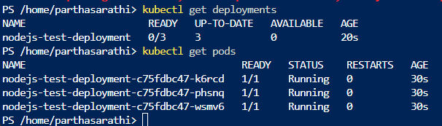

Check for the usage on pods

Now delete the extension and reinstall the extension for backup

Else can navigate to extensions and delete the extension

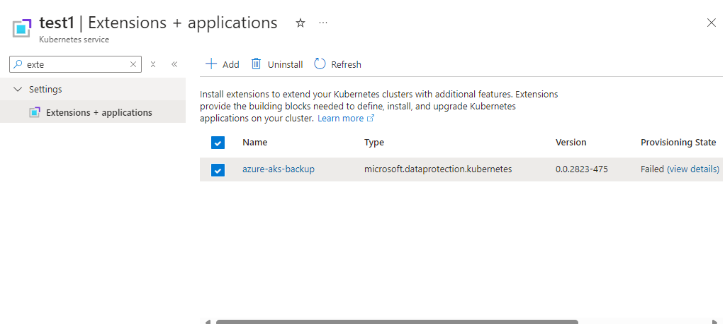

Note- AKS cluster and storage account should be in same location. But it can be in any resource group.

After successfully installing extension configure backup  
  
Select an Backup Vault or create a new. Don’t create Recovery service vault aks backup required Backup Vault.

If creating Vault select backup redundancy LRS or GRS

Q-> RSV need to be in same region or not?

* The Recovery Services Vault (RSV) should indeed be in the same region as your AKS cluster.

Proceed with RSV to enable backup. If it through the error on access click on providing access.

Choose the backup policy or create new, define backup frequency, backup schedule time, retain policy etc..  
  
Choose the backup scope entire cluster or a namespace

Make sure to check on taking backup for keys and secrets for the cluster.

Q -> **Sent by you:**

not getting, i am having 2 instances in aks node pool, do i need to provide one of the existing node name here? what will be use of this instance will it start running immideatly where it will place???

Ans->

No, you don’t need to provide the name of one of your existing AKS node instances. The **Backup Instance Name** is not related to the nodes in your AKS cluster. Instead, it’s a logical name used to identify the backup configuration within the Azure Backup vault.

**Clarification on Backup Instance Name**

* **Backup Instance Name**: This is a unique identifier for the backup configuration. It helps you manage and reference the specific backup instance in the Azure Backup vault. It does not correspond to any physical or virtual node in your AKS cluster.

**Purpose and Behavior**

* **Purpose**: The Backup Instance Name is used to organize and manage your backup configurations. It allows you to easily identify and manage different backup instances, especially if you have multiple backup configurations for different applications or environments.
* **Behavior**: When you configure a backup for your AKS cluster, the backup process will start according to the schedule defined in your backup policy. The backup instance will not start running immediately unless you trigger an on-demand backup. The backups will be stored in the Azure Backup vault.

**Example**

Let’s say you have an AKS cluster with two node instances and you want to back up your application data:

1. **Backup Instance Name**: my-aks-backup-instance
2. **Backup Policy**: daily-backup-policy
3. **Retention Period**: 30 days

This configuration ensures that your application data is backed up daily and retained for 30 days. The backup process will run according to the schedule, and the backups will be stored in the Azure Backup vault.

Proceed with validation

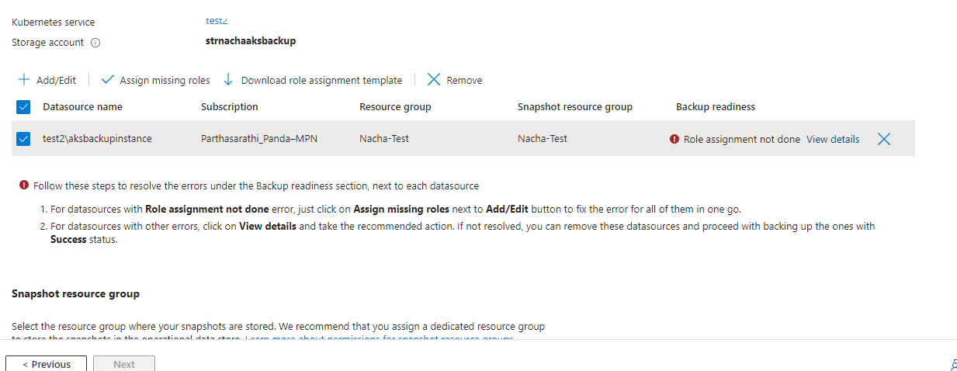

Error-

Role is missing, assign missing role.  
  
Select existing Vault to use for backup or can create new ( vault and aks should in in same region)  
  
NOTE- for enabling backup the vault and the the server must be in same zone.

It will move for re validation once the re validation is done move to next step.

Check the configuration and configure backup.

Once the deployment is done. Go to backup vault and check the configuration. Also can trigger backup.

The backup instance name we had given at the time of configuration we will see that instance name on the backup items.

Once the backup is completed we can see the backup data.

Can see the backup data on storage account.

If any criticality triggered and the cluster damaged we can restore the cluster.

Go to backup instance and select restore option.

Select the restore point from which we want to restore.

Select where do we want to restore, on any of the the existing cluster. That can be on any region and on any resource group.

Also can choose which namespace or the entire cluster need to restore.

Go for validation. It will take few minutes.

And we can restore.

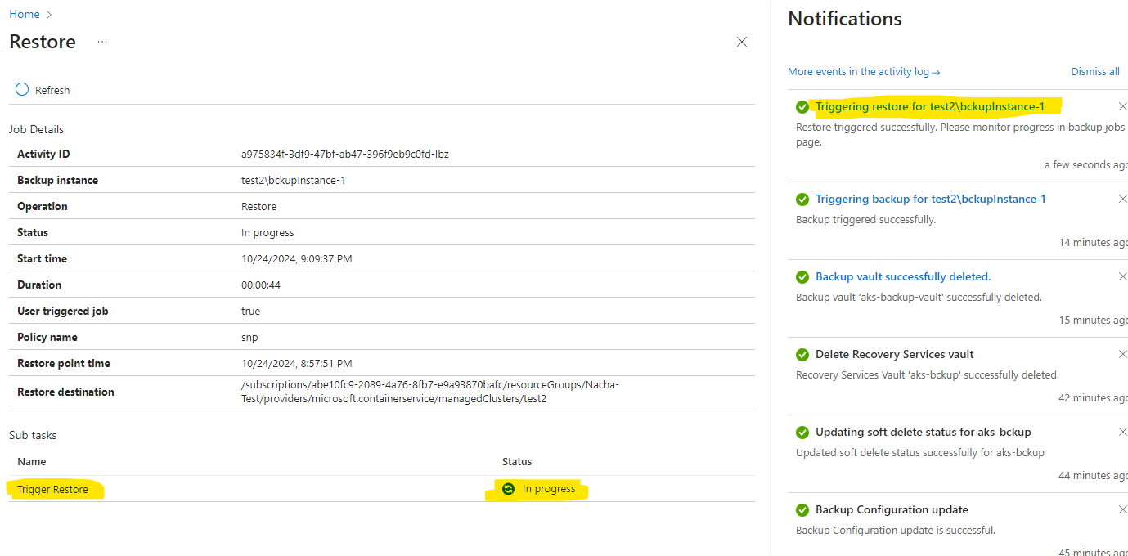

Once the restoration is done we can check for cluster and it’s working properly.

Required role for backup vault aks

* 1. [Key Vault Administrator](https://portal.azure.com/)
  2. [Owner](https://portal.azure.com/) inherited from subscription